

Indoor Play Center manufacturer in China 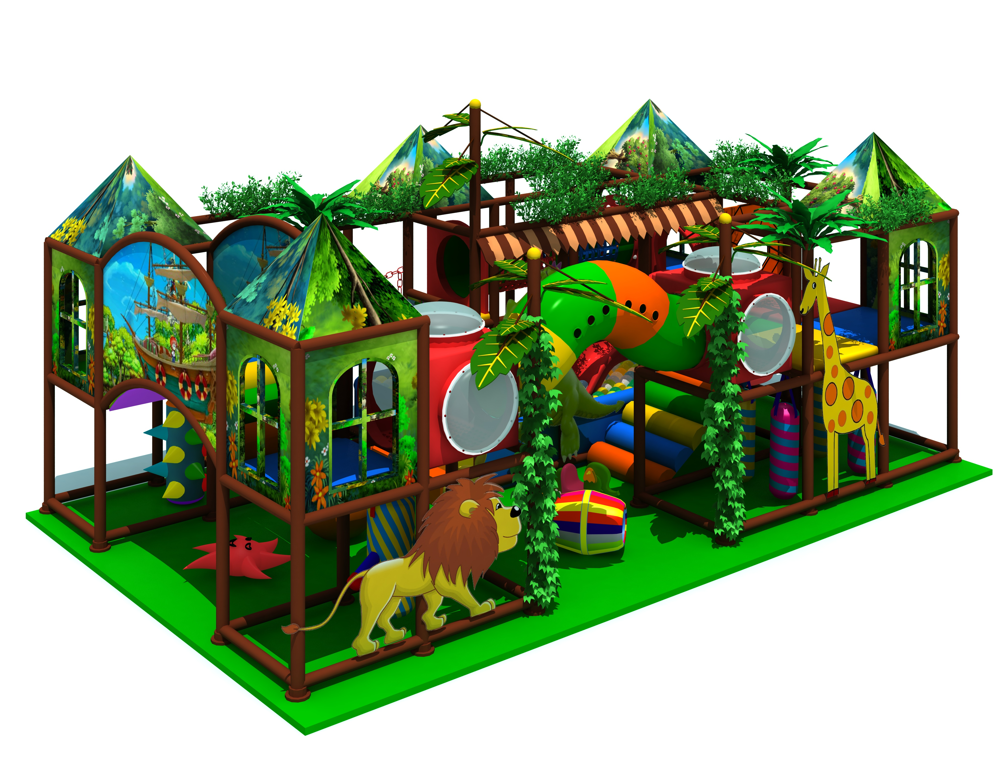
Item Code: 5.LE.B9.511.301.09
Unit Size (mm): 65*33*5.2m
Material:
- Plastic part: LLDPE
2.Gavanized steel,Dia 48mm
3.Pipe thickness:1.5mm
4.PE netting
5.EVA floor carpet
Age range: 4-12 years old

Capacity: 50-70persons
Playground floor height: 1.4meter/each floor
Packing Volume (CBM): 240
