

Kids Indoor Playground for Family Entertainment 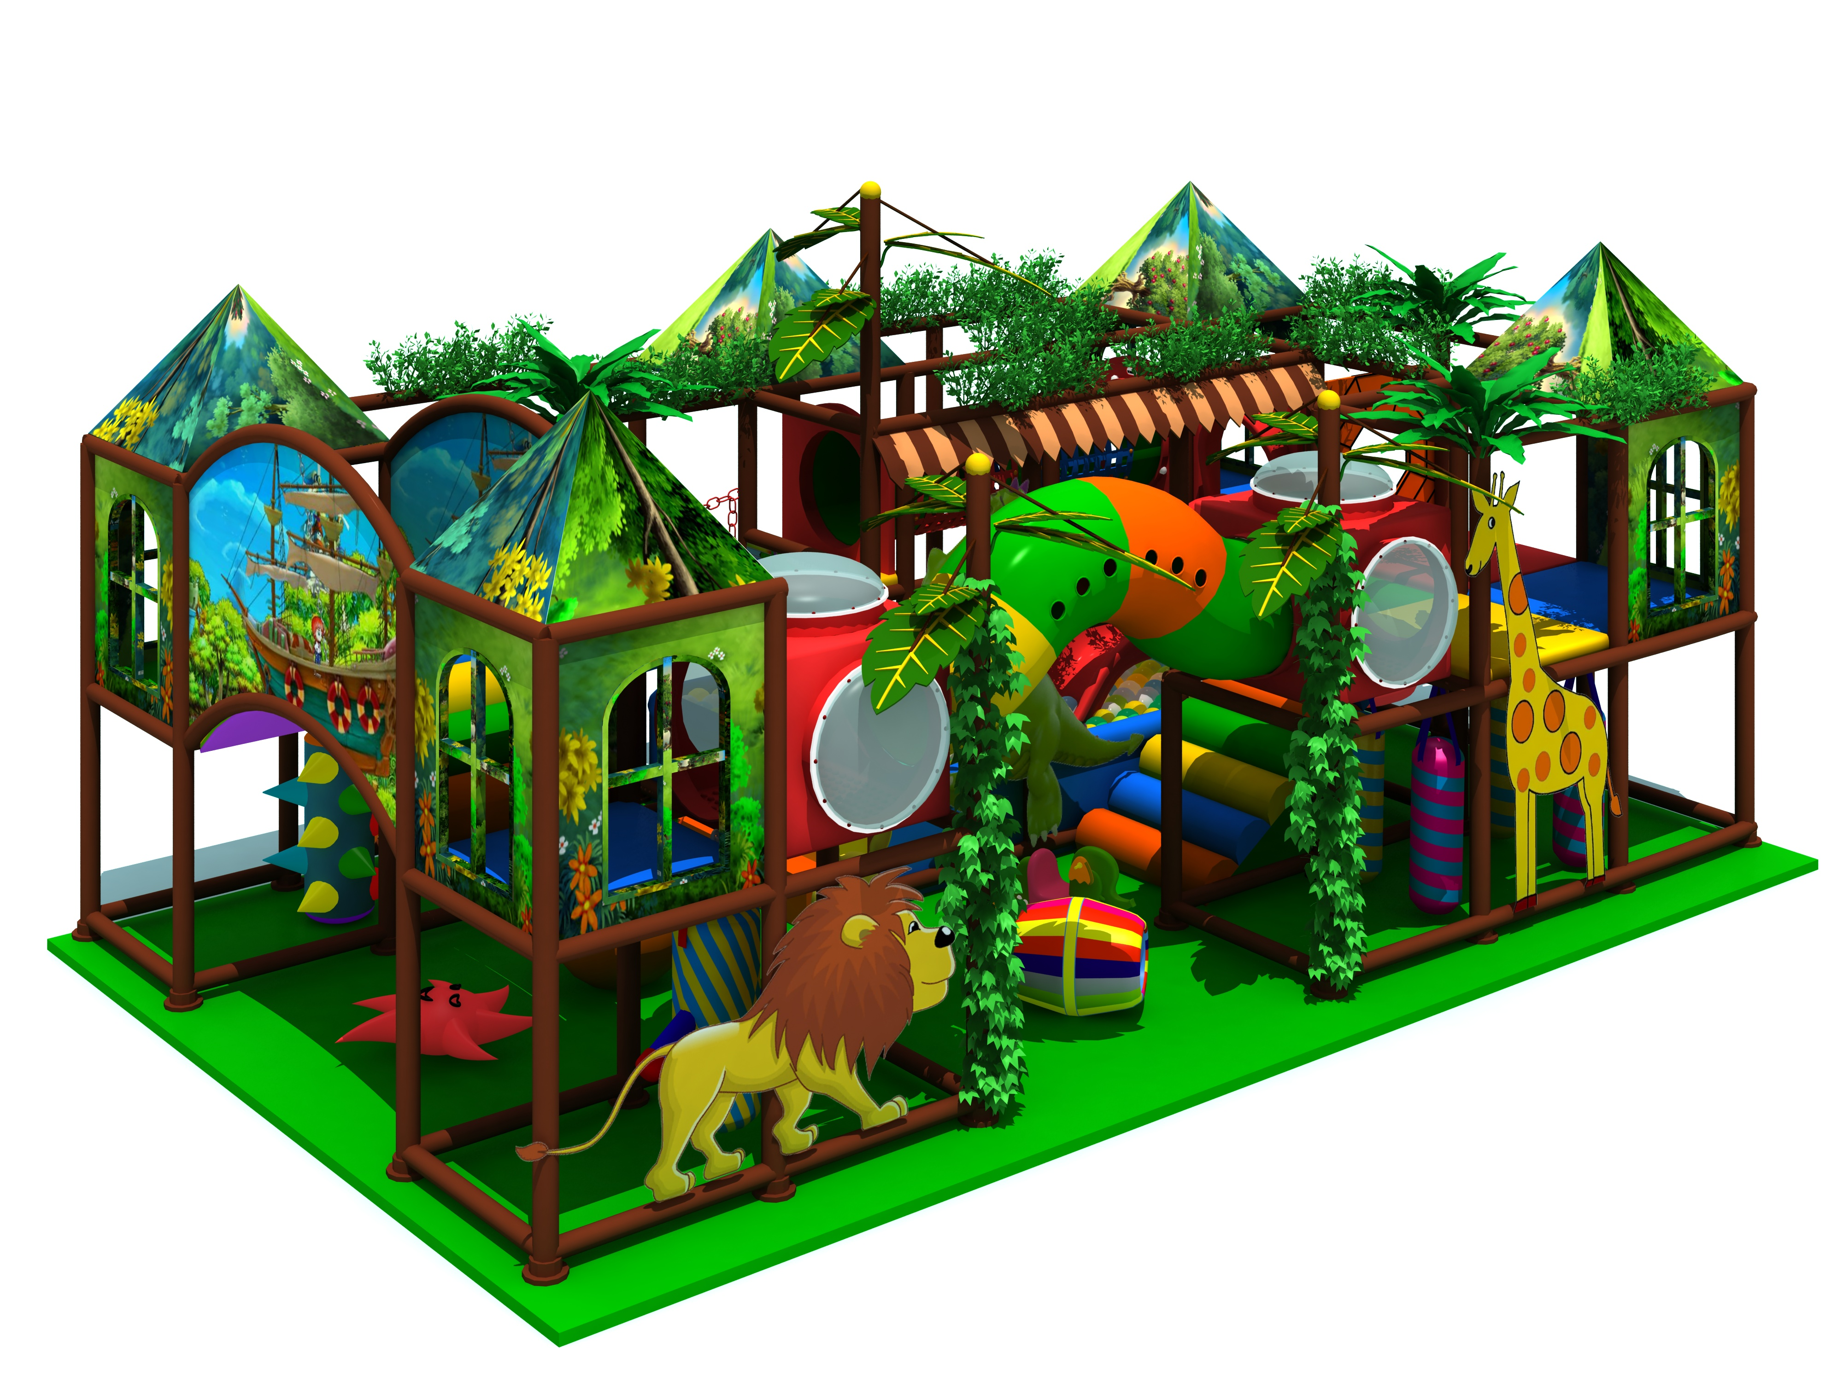
Item Code: 5.LE.T3.605.061.01
Unit Size (mm): 8*7.5*2.6m
Material:
- Plastic part: LLDPE
2.Gavanized steel,Dia 48mm
3.Pipe thickness:1.5mm
4.PE netting
5.EVA floor carpet
Age range: 4-12 years old

Capacity: 20-30 persons
Playground floor height: 1.4meter/each floor
Packing Volume (CBM): 25
