

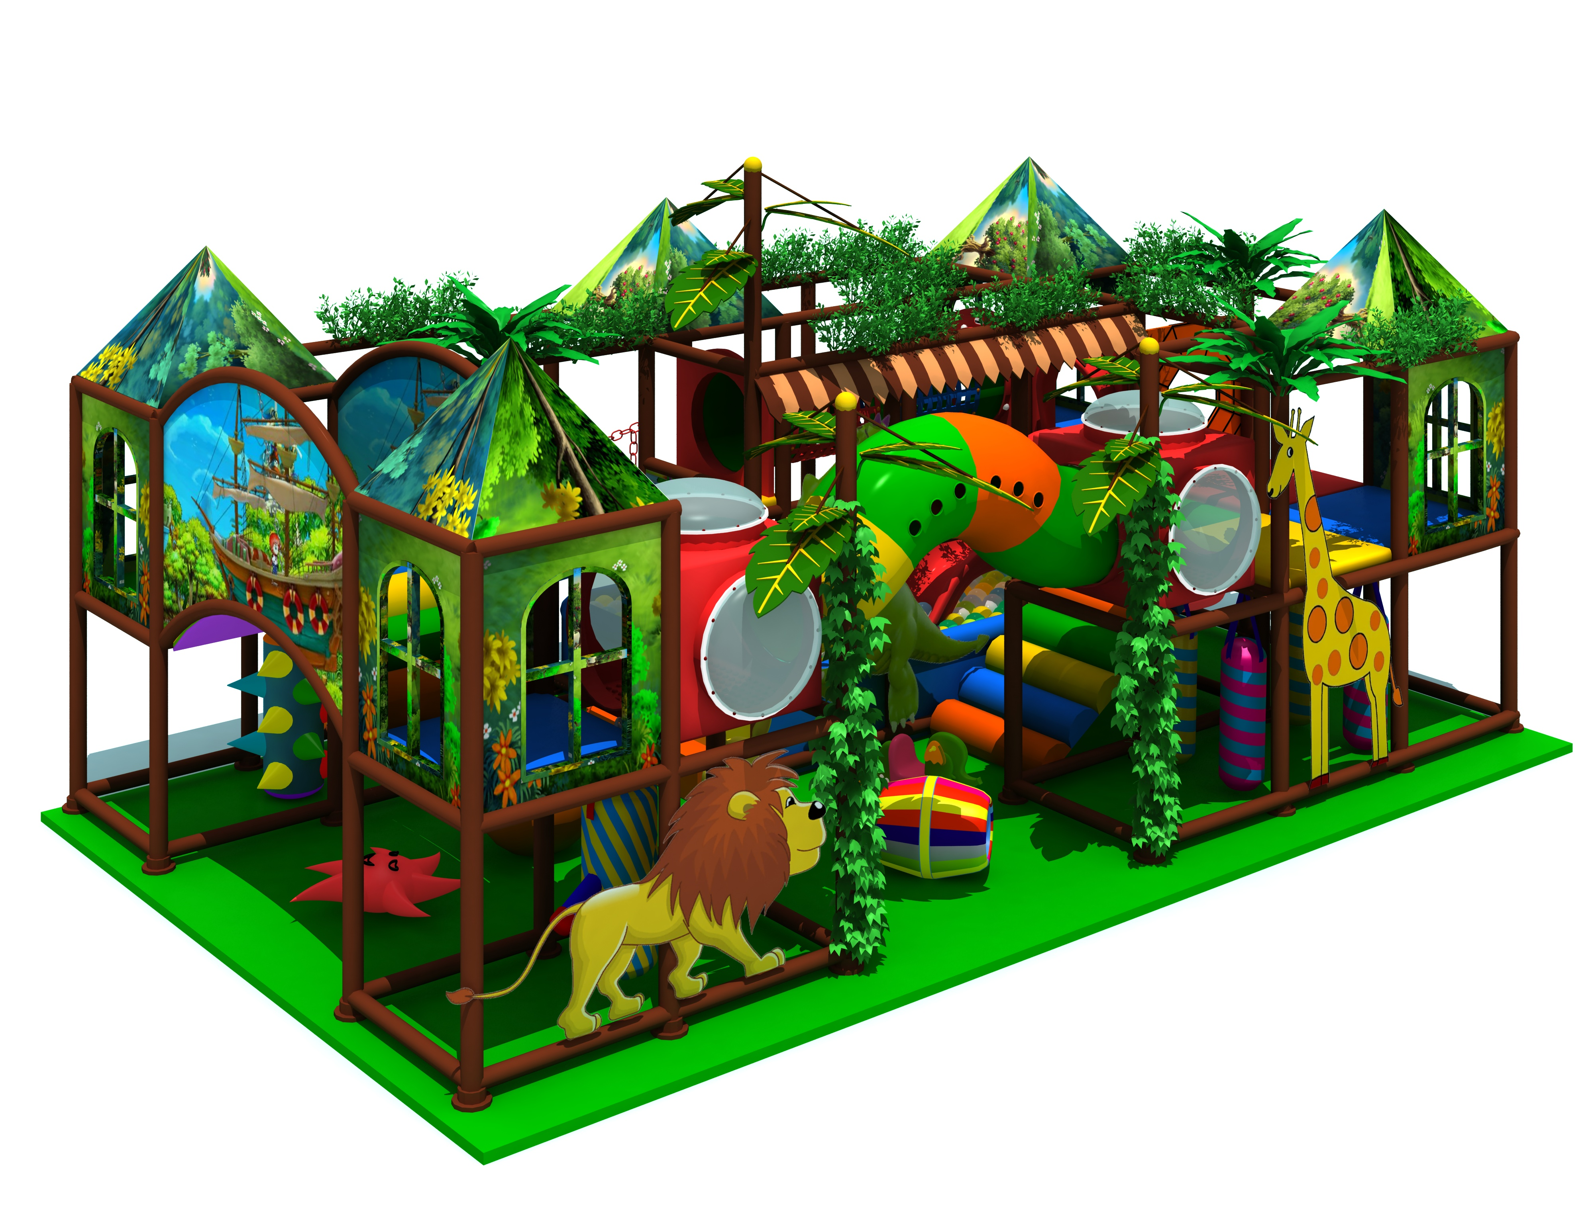
Indoor Play Center for Family Entertainment
Introduction of Indoor Play Center for Family Entertainment
Item Code: 31*17.8*3.4m
Material:
- Plastic part: LLDPE
2.Gavanized steel,Dia 48mm
3.Pipe thickness:1.5mm
4.PE netting
5.EVA floor carpet
Age range: 4-12 years old
Playground floor height: 1.4meter

