
Kids Indoor Playground Equipment for Sale 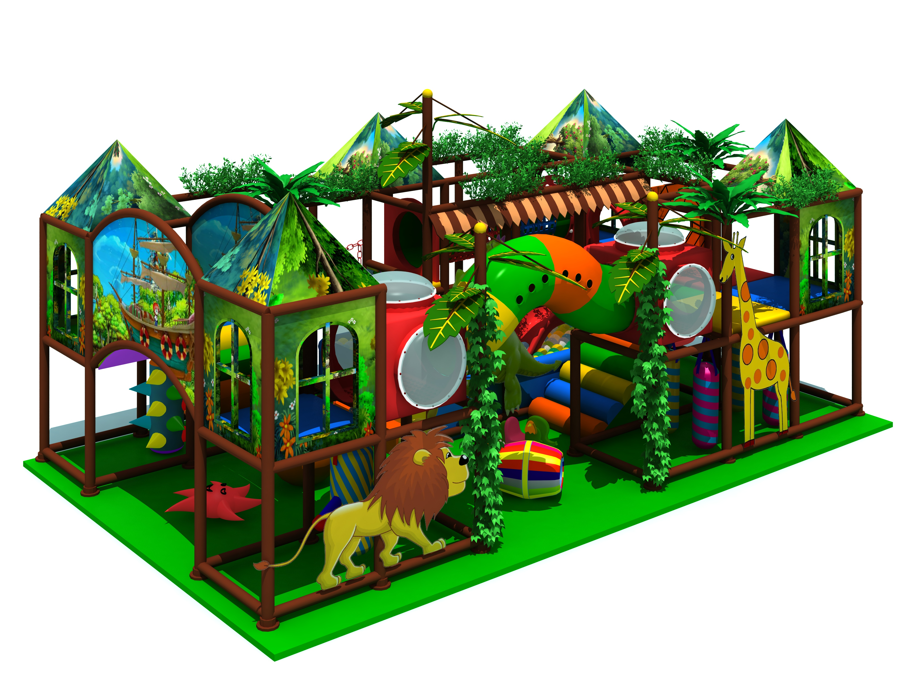
Item Code: 5.LE.T3.609.061
Unit Size (mm): 23*22*6.2m
Material:
- Plastic part: LLDPE
2.Gavanized steel,Dia 48mm
3.Pipe thickness:1.5mm
4.PE netting
5.EVA floor carpet
Age range: 4-12 years old

Capacity: 50-70persons
Playground floor height: 1.4meter
Packing Volume (CBM): 75
