

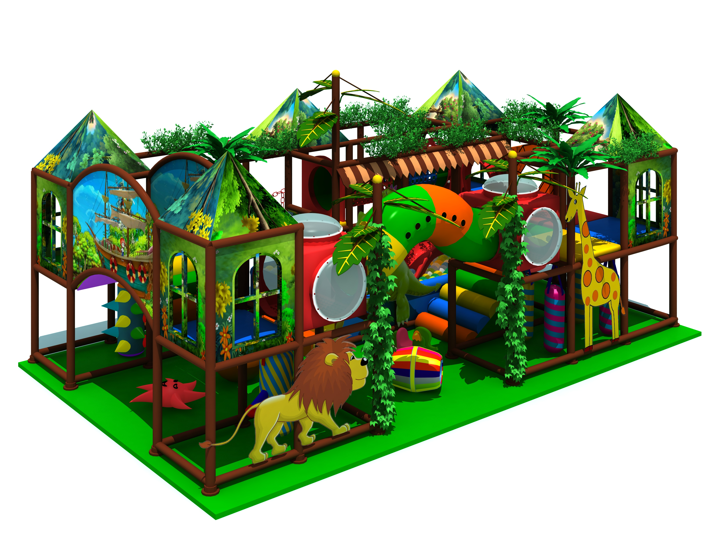
Colorful Kids Indoor Play Centre
Introduction about Colorful Kids Indoor Play Centre
Item Code: 5.LE.T6.606.131.00
Material:
- Plastic part: LLDPE
2.Gavanized steel,Dia 48mm
3.Pipe thickness:1.5mm
4.PE netting
5.EVA floor carpet
Age range: 4-12 years old
Playground floor height: 1.4meter

