

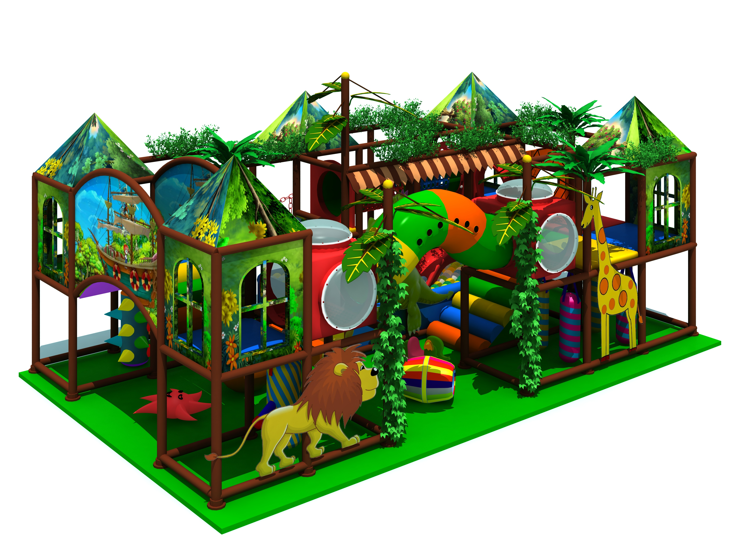
Kids Indoor Play for Amusement in China

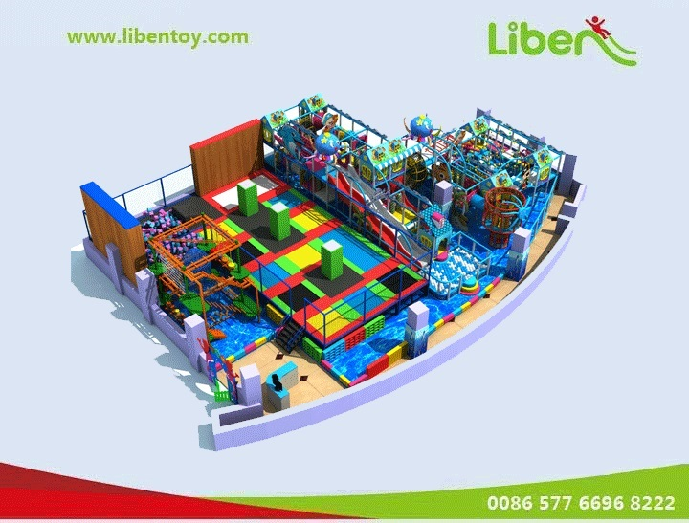
Introduction about Kids Indoor Play for Amusement in China
Item Code: 5.LE.T5.606.170.05
Material:
- Plastic part: LLDPE
2.Gavanized steel,Dia 48mm
3.Pipe thickness:1.5mm
4.PE netting
5.EVA floor carpet
Age range: 4-12 years old
Playground floor height: 1.4meter

