

Indoor Playground Equipment

Kids Indoor Playground Equipment
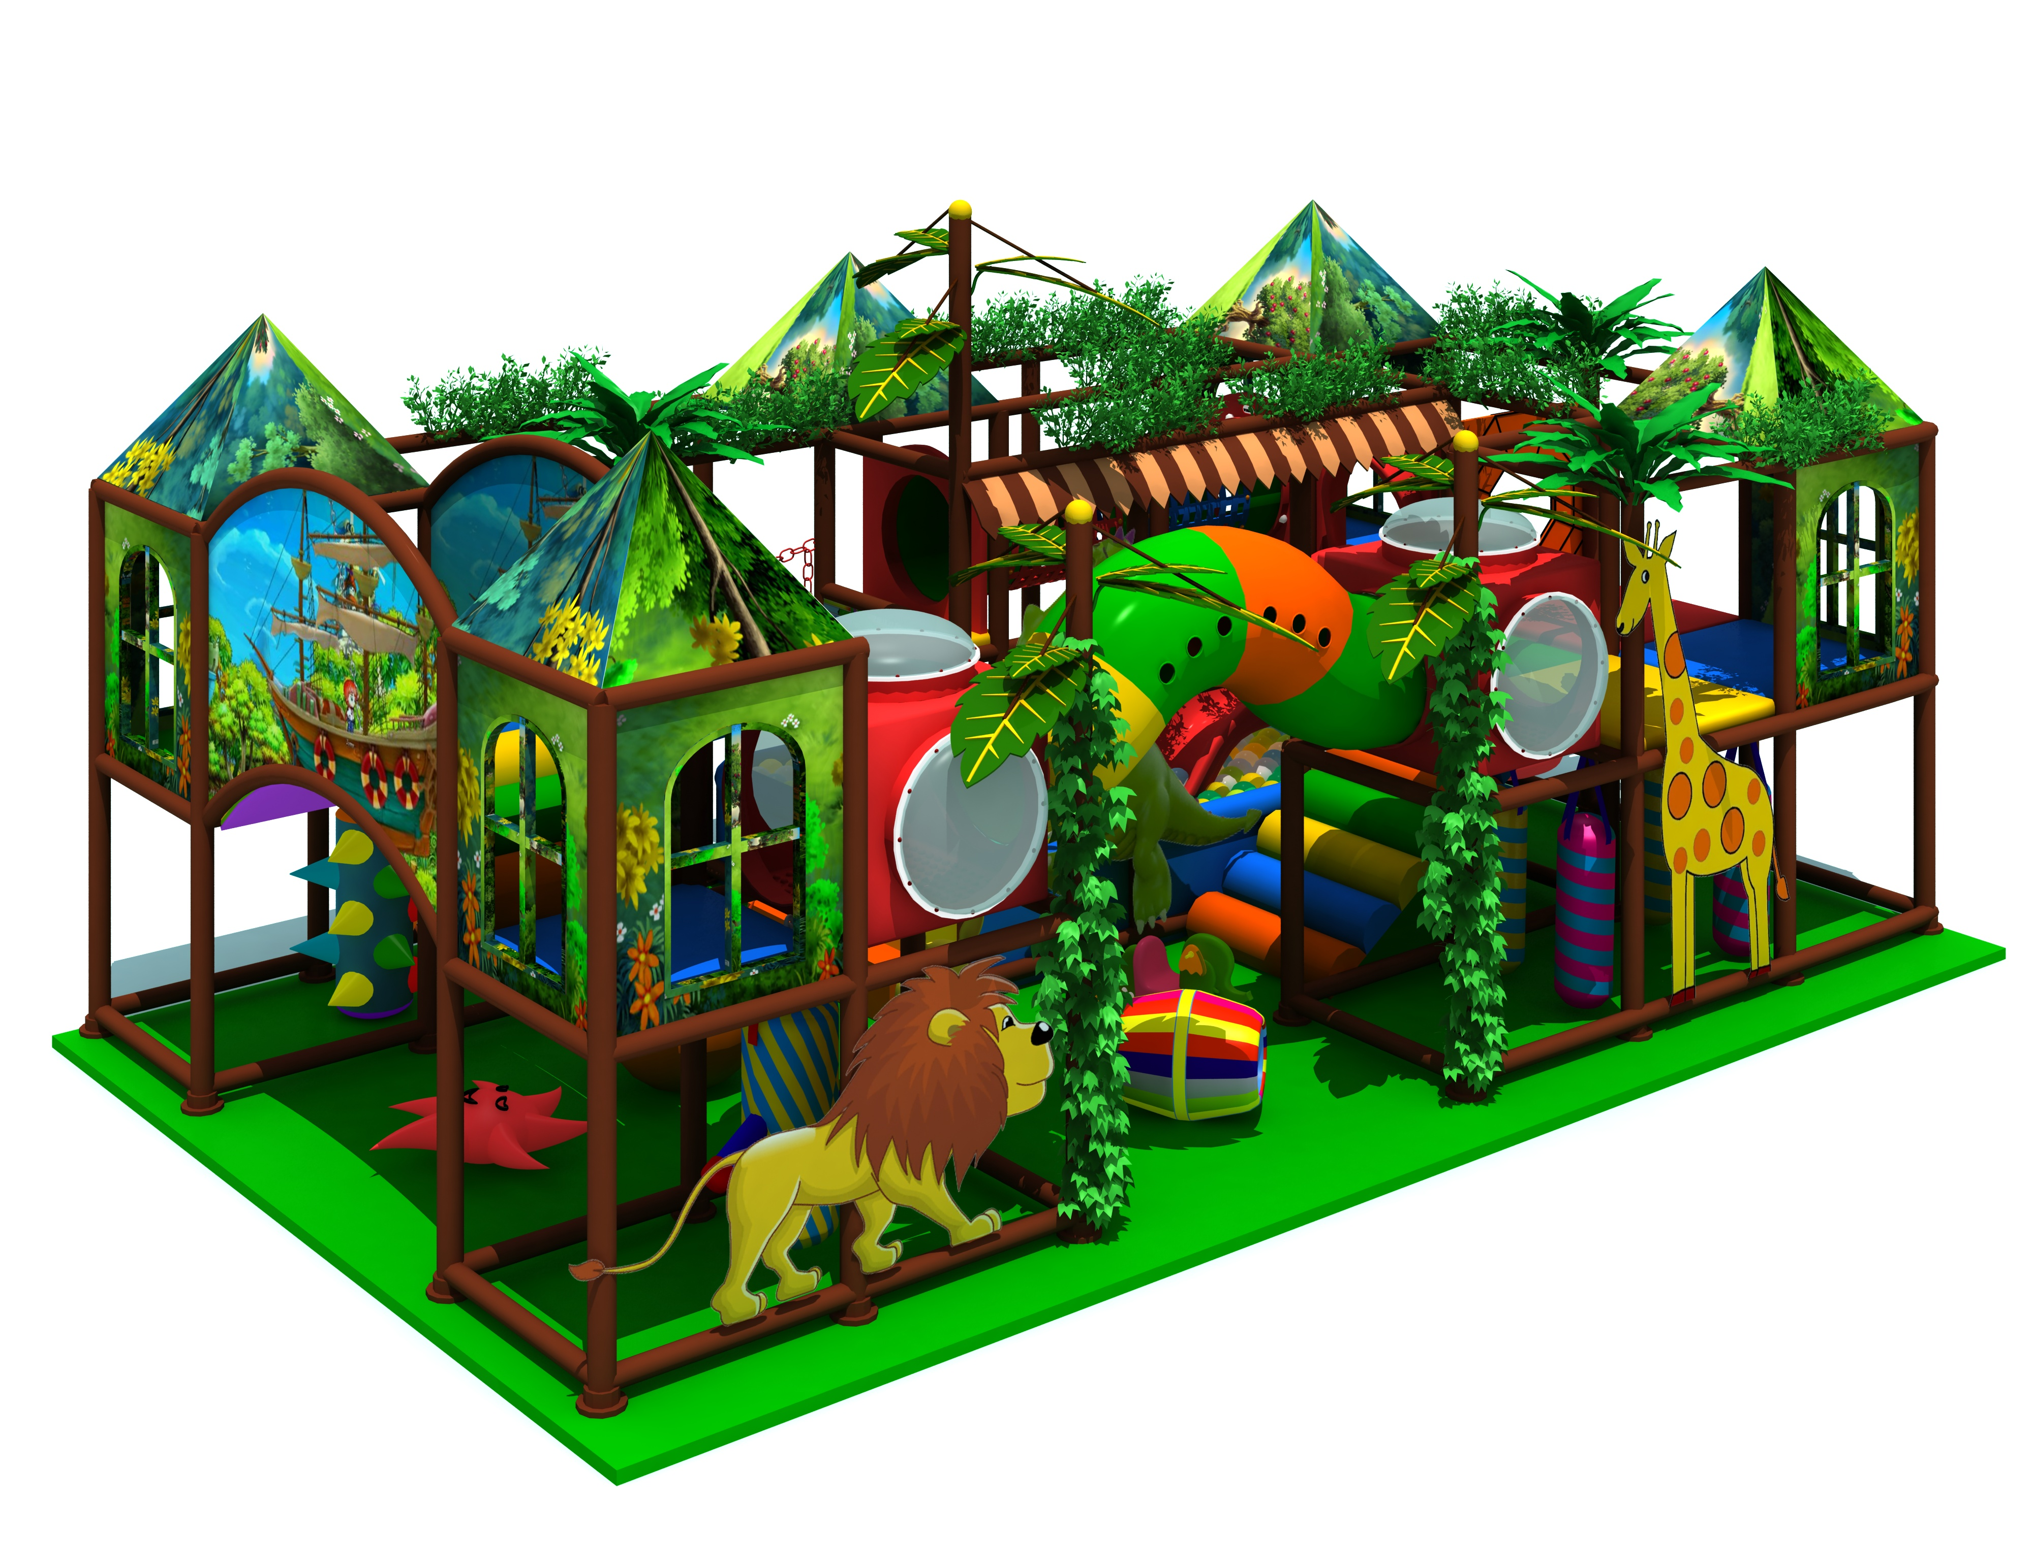

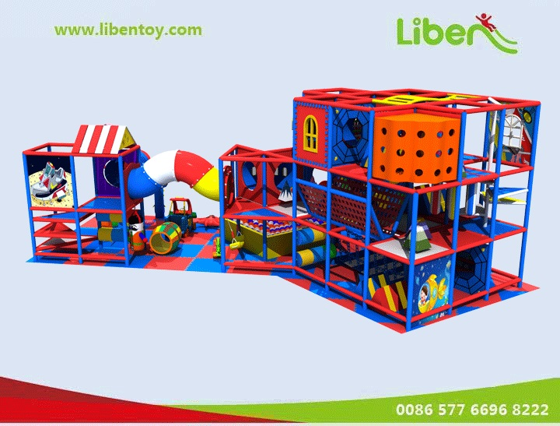
Introduction about Kids Indoor Playground Equipment
Item Code: 5.LE.T3.607.241
Unit Size (mm): 12000*4500*4200
Material:
- Plastic part: LLDPE
2.Gavanized steel,Dia 48mm
3.Pipe thickness:1.5mm
4.PE netting
5.EVA floor carpet
Age range: 4-12 years old
Playground floor height: 1.4meter

