

Indoor Playground Equipment

Indoor Play Area for Kids

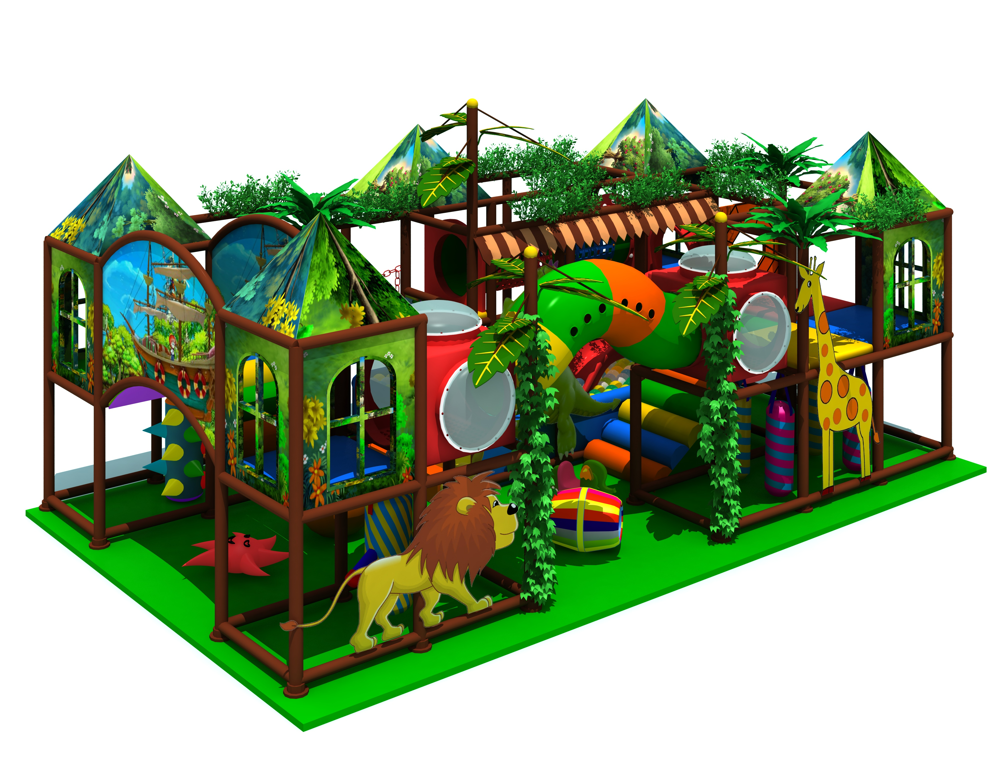

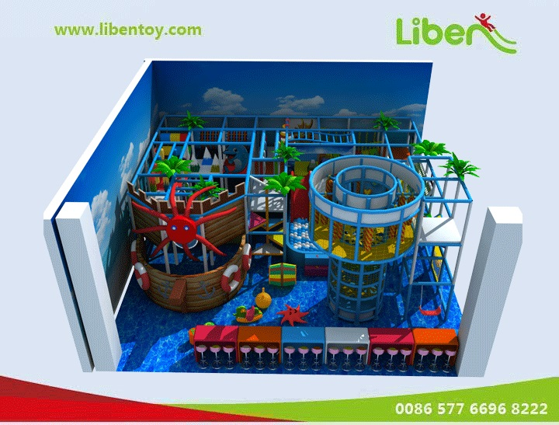
Introduction about indoor play area for kids
Item Code: 5.LE.T3.607.201
Unit Size (mm): 11000*10550*5000
Material:
- Plastic part: LLDPE
2.Gavanized steel,Dia 48mm
3.Pipe thickness:1.5mm
4.PE netting
5.EVA floor carpet
Age range: 4-12 years old
Playground floor height: 1.4meter

