

Indoor Playground Equipment

Indoor playground Design
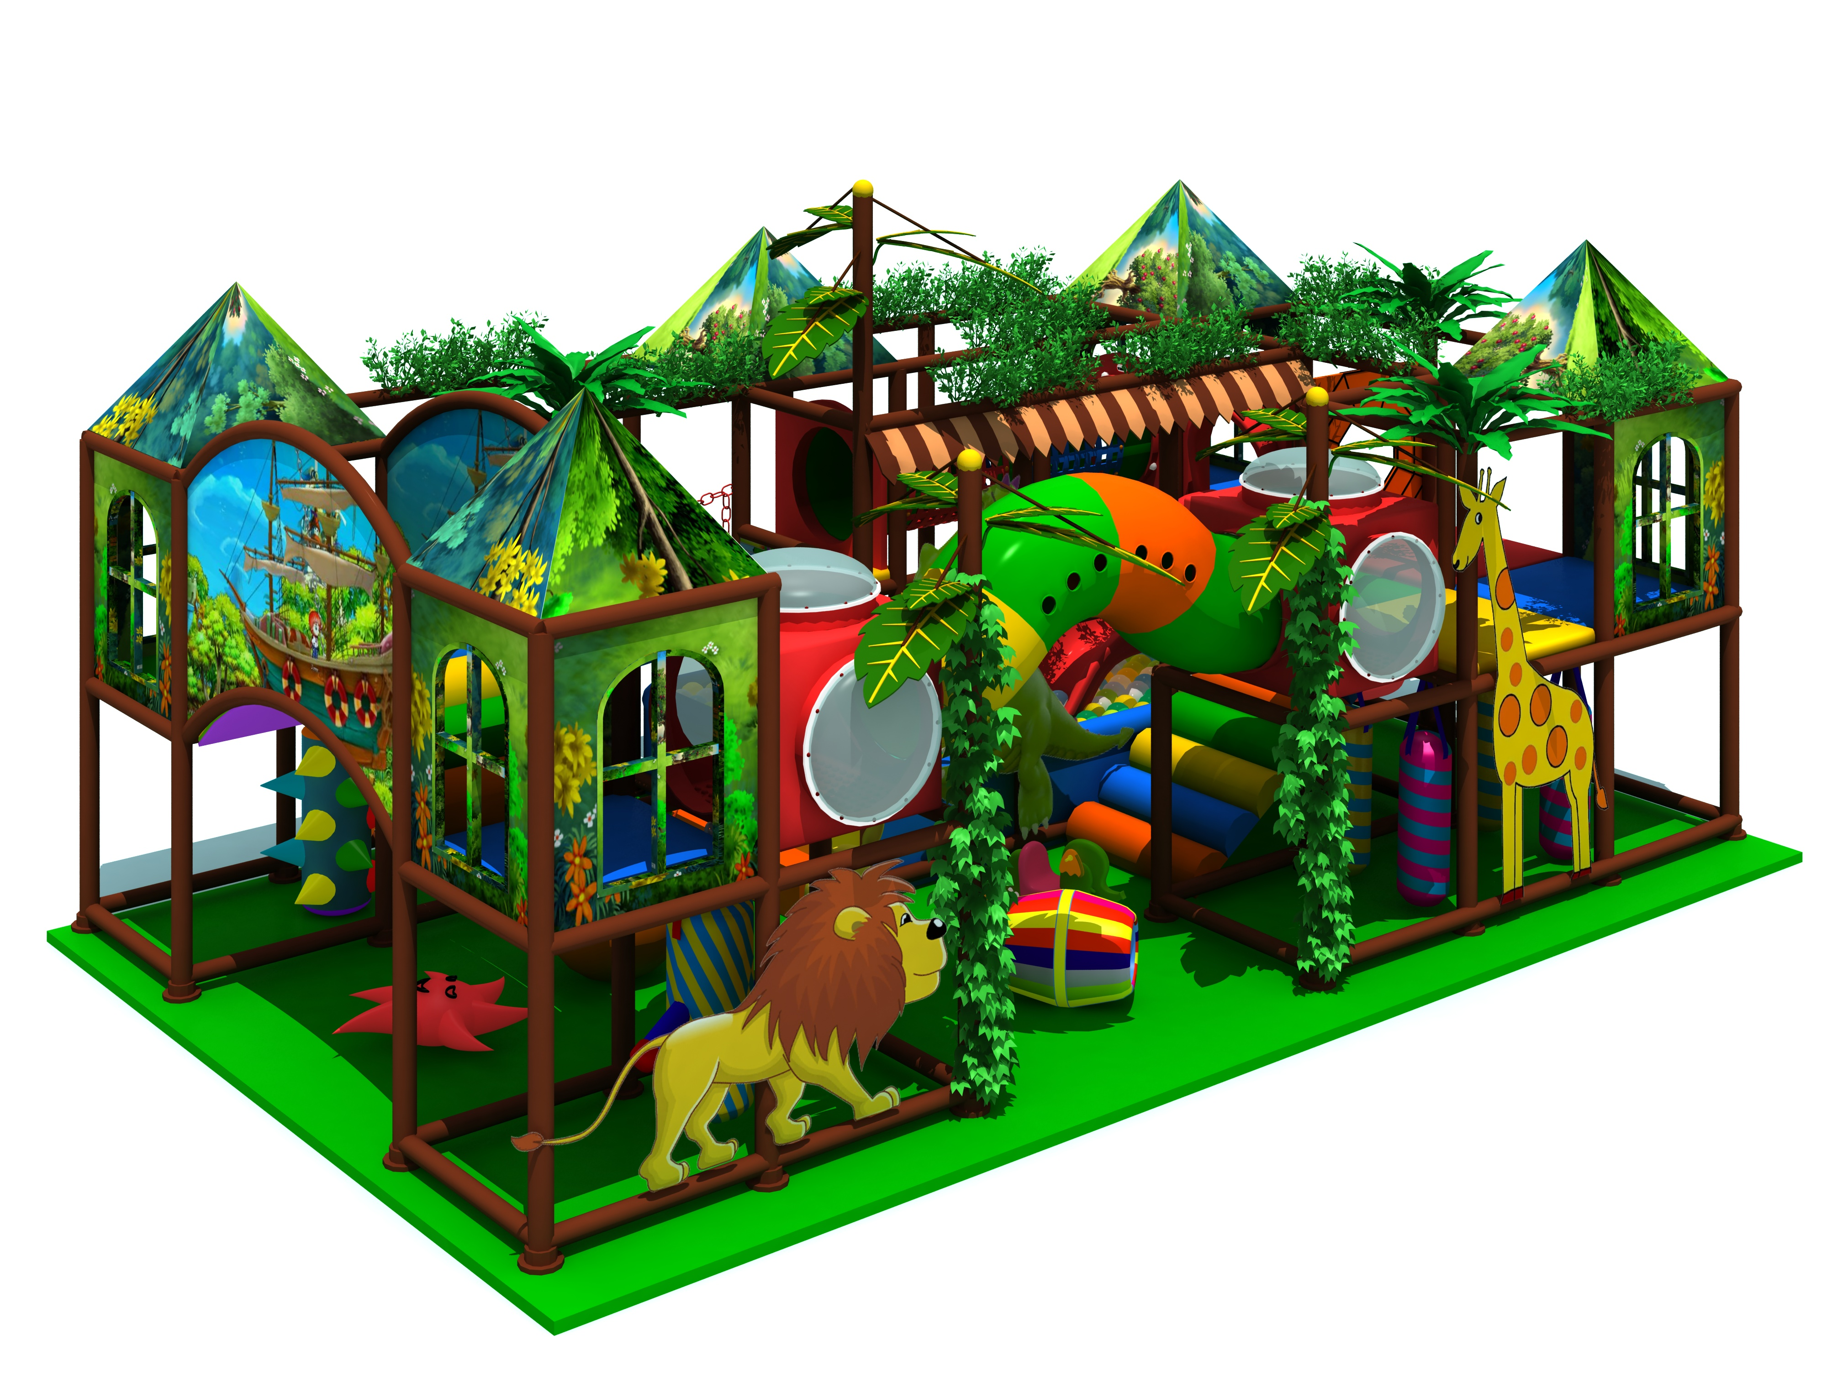
Item Code: 5.LE.T6.606.251.00
Unit Size (m): 9.93*6.62*4.87m
Material:
- Plastic part: LLDPE
2.Gavanized steel,Dia 48mm
3.Pipe thickness:1.5mm
4.PE netting
5.EVA floor carpet
Age range: 3-12 years old

Capacity: 20-30persons
Playground floor height: 1.4 meter
Packing Volume (CBM): 75
