

Indoor Playground Equipment

Indoor playground Design
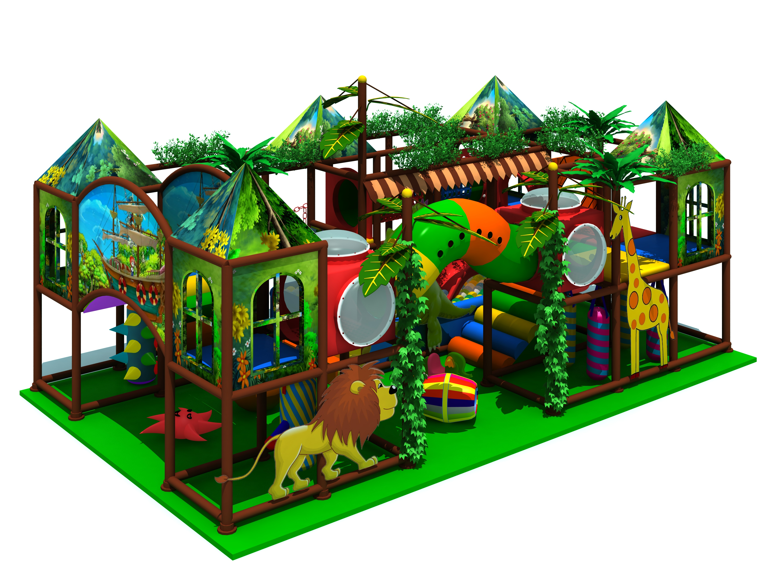
Item Code: 5.LE.T3.605.091.01
Unit Size (m): 6.21*3.74*2.85m
Material:
- Plastic part: LLDPE
2.Gavanized steel,Dia 48mm
3.Pipe thickness:1.5mm
4.PE netting
5.EVA floor carpet
Age range: 3-12 years old

Capacity: 10-20persons
Playground floor height: 1.4 meter
Packing Volume (CBM): 75
