

Indoor Trampoline Park

Indoor Trampoline Design
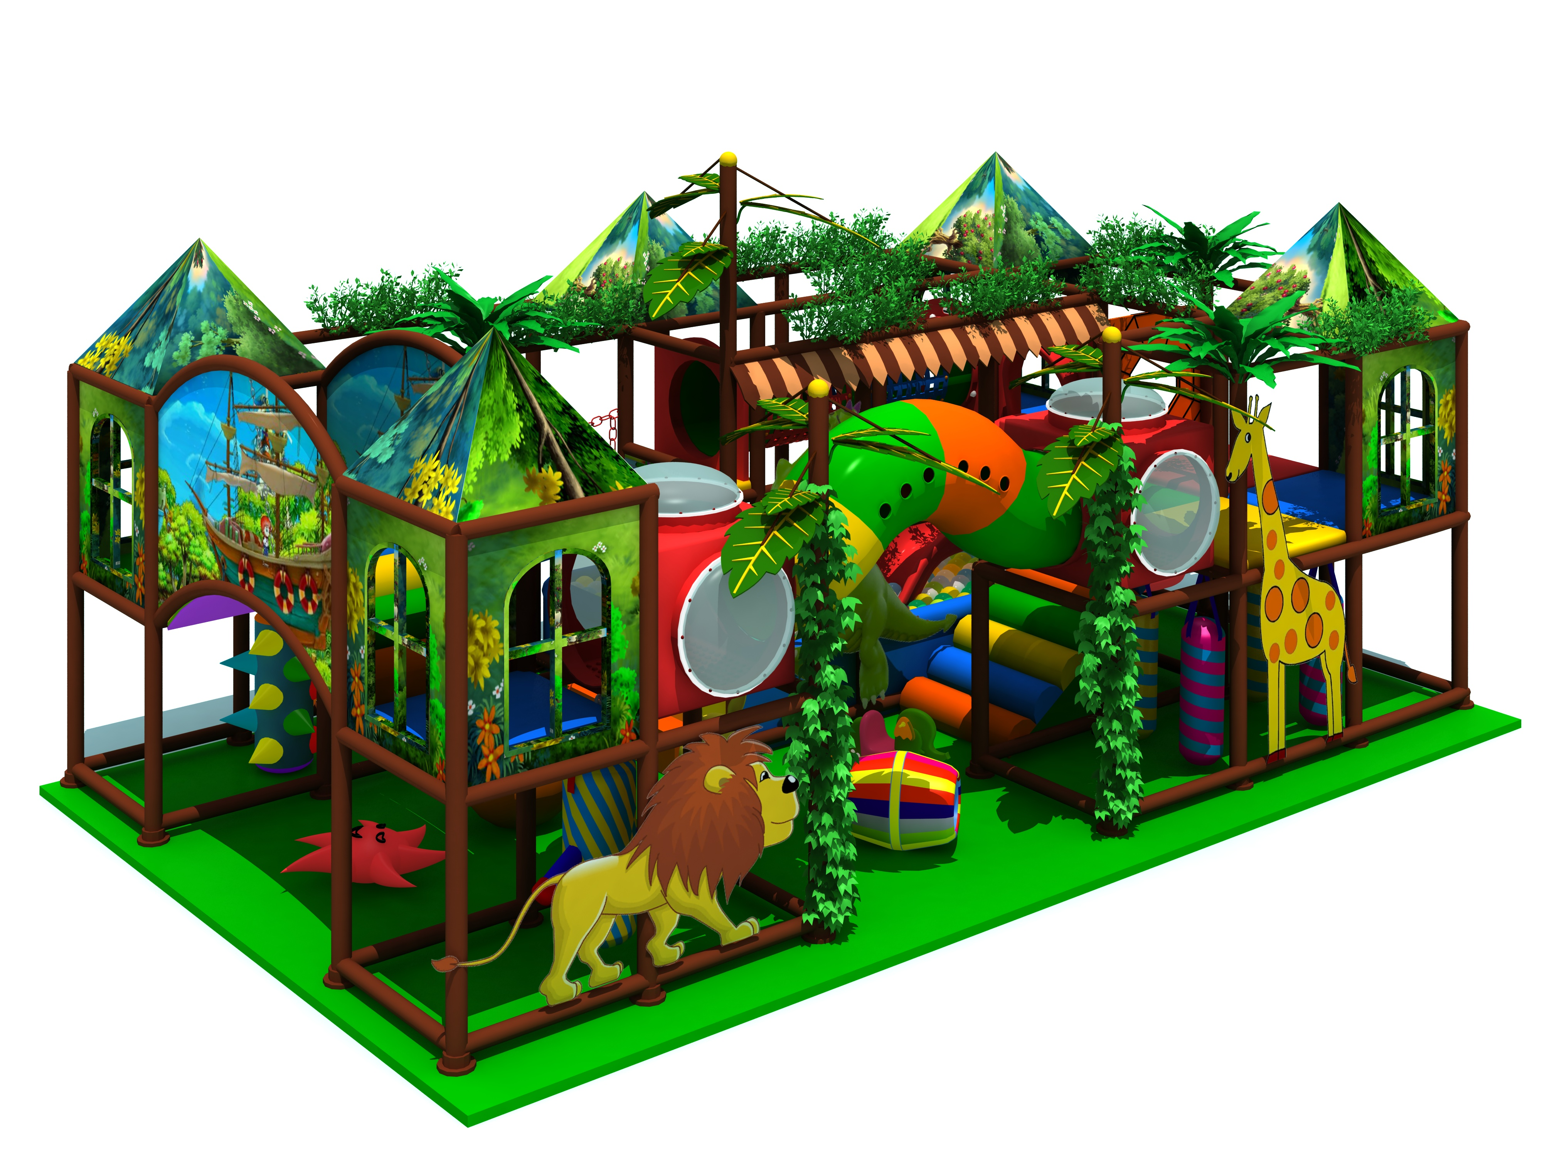

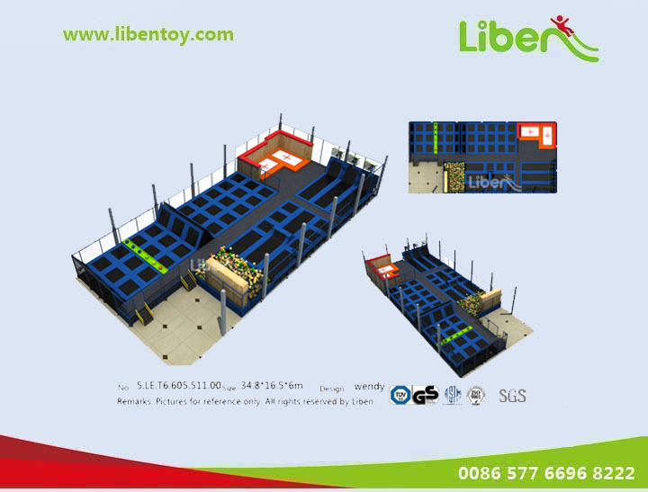
Item Code: 5.LE.T6.605.511.00
Unit Size (m): 34.8*16.5*6m(L*W*H)
Material:
1. Steel Framed Structure
1). Upright structure of galvanized steel pipe 100*100*2.0mm;
2). "T" shaped structure of galvanized steel pipe 100*50*2.5mm;
3). "A" shaped structure of galvanized steel pipe 100*50*2.5mm;
4). Enhanced connecting structure of galvanized steel pipe 40*40*2.0mm.
2. Trampoline Mats
1). PP for normal trampoline beds (distance between each spring: 130mm);
2). Poly-amide yarns (nylon yarns) for gymnastic trampoline beds (distance between each spring: 110mm);
3). Size: 1760*1760mm of common trampoline beds; 4260*2130mm of gymnastic trampoline beds.
3. Safety Padding
Safety paddings are made from 0.46mm thick matt PVC leather plus 11mm thick XPE sponge.
4. Stiffeners and Springs
1). 40*40mm of galvanized steel for enclosure (safety net). 3.25*180mm of carbon steel wire spring for securing the common trampoline beds;
2). 3.25*260mm of carbon steel wire springs for securing the gymnastic trampoline beds (4.0*265mm of piano wire spring will be used in the four corners of the beds);
3). Other accessories like screws are all stainless.

