

Indoor Playground Equipment

Indoor playground Design
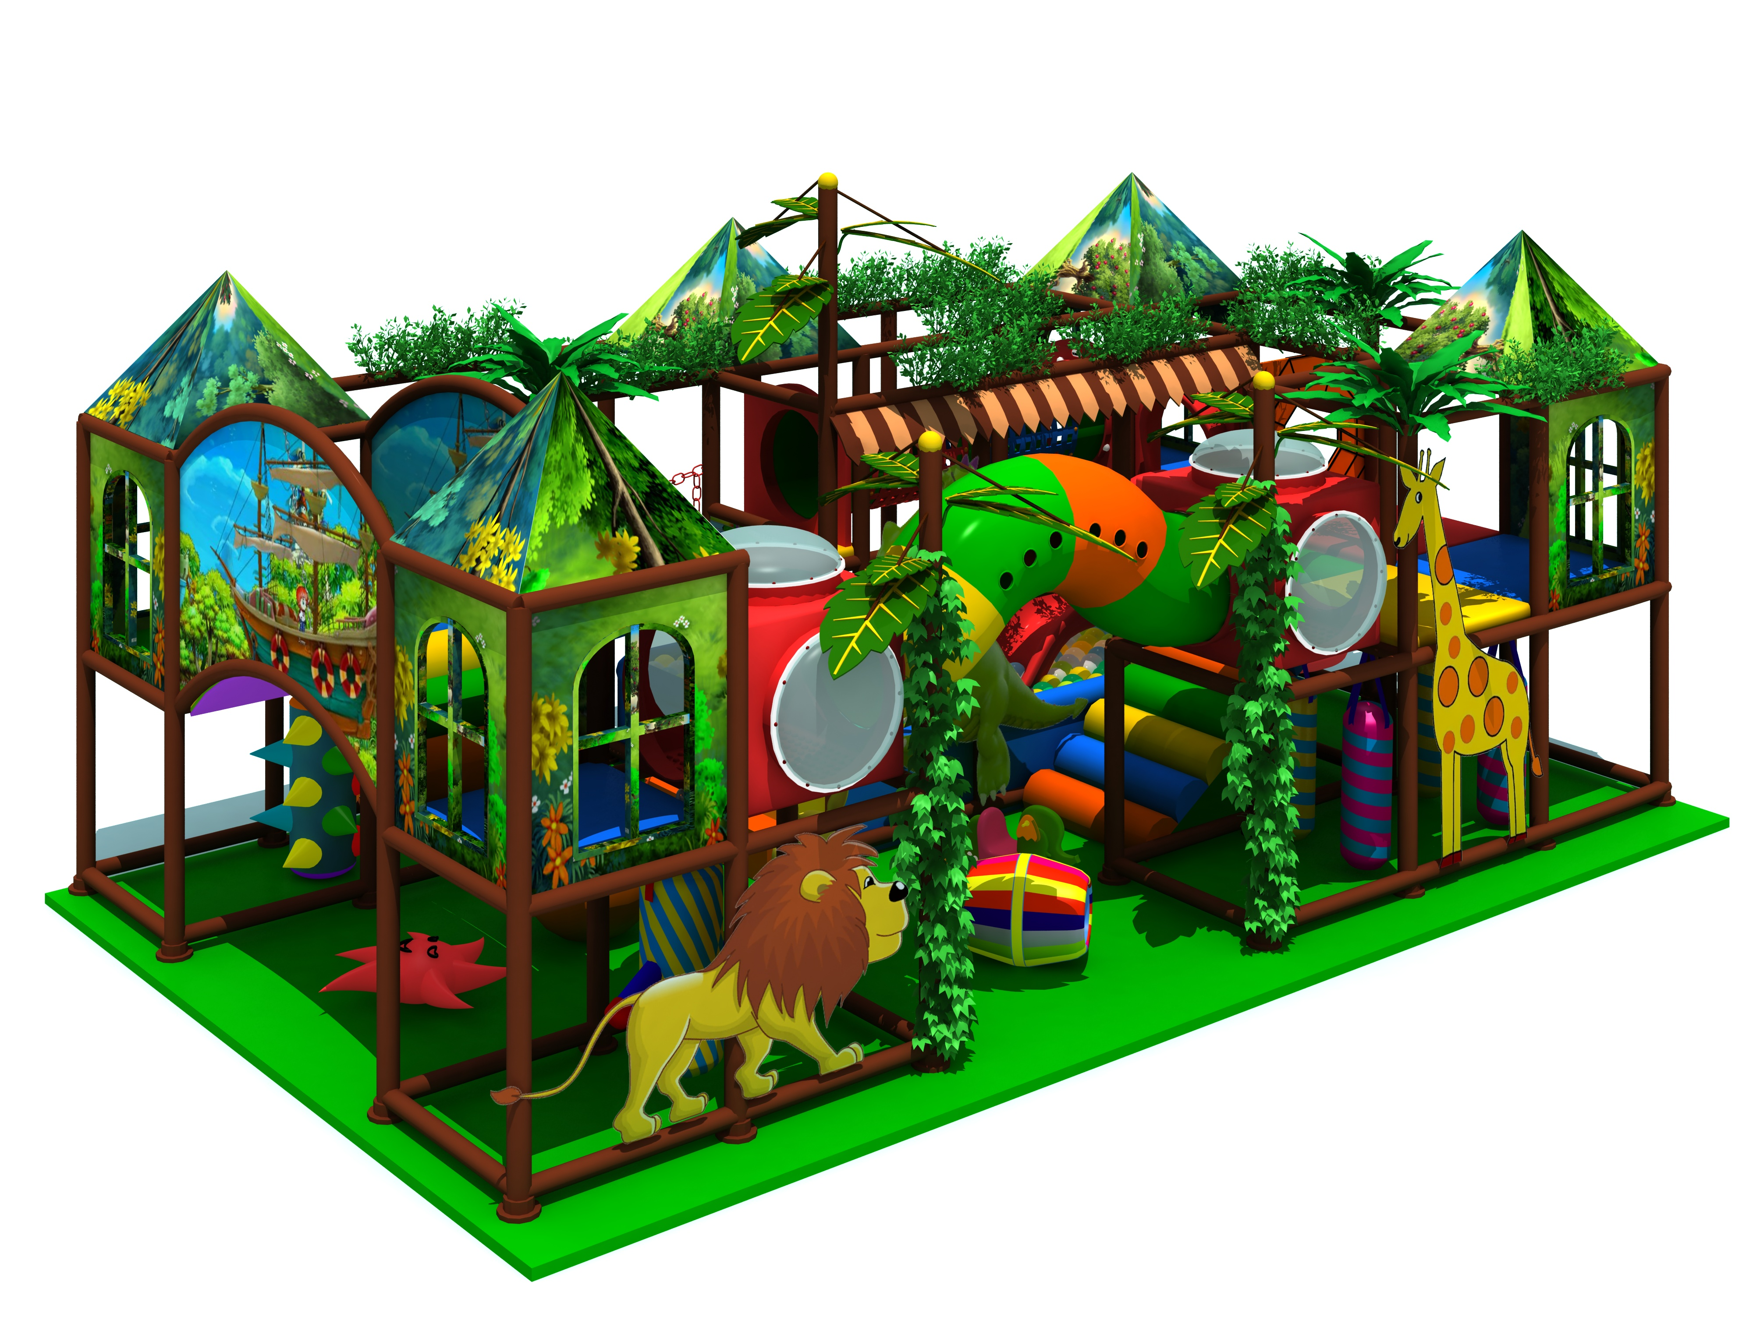
Item Code: 5.LE.T6.604.282.01
Unit Size (mm): 2508*1753*4660
Material:
- Plastic part: LLDPE
2.Gavanized steel,Dia 48mm
3.Pipe thickness:1.5mm
4.PE netting
5.EVA floor carpet
Age range: 4-12 years old

Capacity: 50-70persons
Playground floor height: 1.4meter
Packing Volume (CBM): 75
